Here’s a clear format for ordering the new 55” kiosks with specifications and notes as per our discussion. Please add the logo size and notes to Mirinda.

Brandm3dia Standard Specification for 55” Touch Kiosks

Core Specifications:
- Screen Size: 55” touch display.
- Audio: Integrated speakers with a maximum output of 18W.
- Mount: Adjustable, changeable bracket compatible with Lenovo computers (e.g., ThinkCentre and mini computers).

Connections for Video Input:
Most of the computers here have two types of display ports:
- DisplayPort (D port)
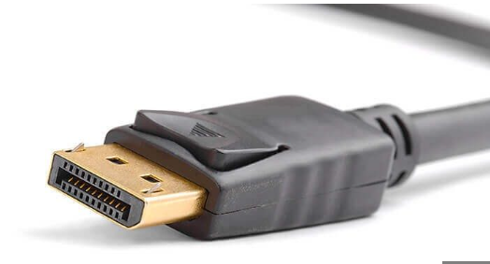
- HDMI 2.1: Supports 4K resolution at 60Hz or higher.
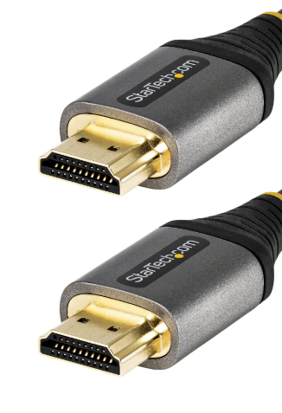

We need both types of connector cables to be routed from the screen to the PC.
- DisplayPort 1.4 or 2.0: Enhanced refresh rates and color accuracy.
- USB-C with DisplayPort Alt Mode: Optional for newer systems.

Stable Touch Input Technologies:
1. Projected Capacitive (PCAP):
- Why it’s stable: Durable, highly responsive, and works well with multi-touch gestures. It’s unaffected by minor wear and tear, making it ideal for kiosks.
- Drawback: Slightly more expensive compared to resistive touch technology.

2. Infrared (IR) Touch:
- Why it’s stable: Provides consistent performance and works even if the screen surface is cracked or dirty. Ideal for large displays like 55” kiosks.
- Drawback: Bulkier frame and slightly less responsive to light touches.

Stable Connection Technologies for Touch Input:
1. USB-C:
- Why it’s stable: USB-C is versatile, offers faster data transfer, and is future-proof. Many newer devices support USB-C for both power and data, making it a stable option for touch input.
- Recommendation: Use USB-C cables with devices that support it, as it reduces complexity and offers robust connections.

2. USB-A to USB-B:
- Why it’s stable: Traditional connection widely supported and reliable for touch screen devices, especially older hardware.
- Recommendation: Use for compatibility with existing systems or older screens.

Wireless Connectivity:
- Integrated Lenovo Wireless Antenna: For built-in Wi-Fi.
- Add-on Option: Built-in 4G/5G SIM card router for enhanced network connectivity.
Durability and Structural Design:
- Screen Back Cover: Improved, reinforced back cover to prevent loosening over time.
- Frame-to-Base Connection: Enhanced structural integrity to reduce instability and ensure consistent touch functionality during use.

Additional Options:
- Cable to Second Panel: Include option to connect a secondary panel via USB (Yes or No).
- Logo Placement: Dedicated area for Brand M3dia branding, with a recommended logo size of 200mm x 100mm for optimal visibility.

Notes:
- The screen should include multiple HDMI and DisplayPort options to allow flexible connections to the computer without the need for converter adapters.
- Ensure the touch screen drivers are compatible with Ubuntu and upgradable via manufacturer or Linux kernel updates.
- Wheels should be lockable for stability during operation.
- Include detailed assembly instructions with specifications for frame reinforcement and base stability.
- Test touchscreen responsiveness with the proposed frame design to confirm consistent performance.

---

This specification document should be used as the standard reference for all future kiosk orders and deployments.

Hardware Security:-
All external outlets, including USB, HDMI, Power button, and Networking ports, should be sealed and not accessible to the public. The location should be on the bottom left corner.
Our computers are Lenovo
Dimension: 18cm x 18 cm x 4 cm
Most of the computers here have two types of display ports:

